Indirect Object

✅ What Is an Indirect Object?
# Source: AI Source: Provided by: [Data Path: Persons Table -> ID Column: 1, Name_En Column: Motasem Essam] -> From: [Chatgpt (GPT-4-turbo)] on [8/4/2025]
An Indirect Object is a noun, pronoun, or noun phrase that tells to whom, for whom, to what, or for what the action of the verb is done.
It comes before the direct object and receives the benefit or target of the action.

🔸 Key Features:
# Source: AI Source: Provided by: [Data Path: Persons Table -> ID Column: 1, Name_En Column: Motasem Essam] -> From: [Chatgpt (GPT-4-turbo)] on [8/4/2025]
- Always used with a direct object.
- Answers:
  - To whom?
  - For whom?
  - To what?
  - For what?
- Usually placed between the verb and the direct object.

🔸 Examples of Indirect Objects:
# Source: Chatbot (GPT-4-turbo) at [8/4/2025]
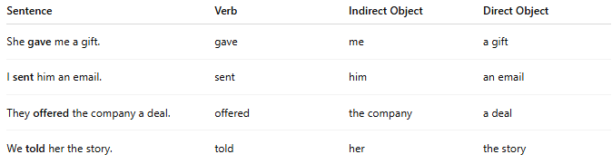
Sentence | Verb | Indirect Object | Direct Object
She gave me a gift. | gave | me | a gift
I sent him an email. | sent | him | an email
They offered the company a deal. | offered | the company | a deal
We told her the story. | told | her | the story

🔸 Rephrased with Prepositions:
# Source: Chatbot (GPT-4-turbo) at [8/4/2025]
You can often rewrite indirect object sentences using a prepositional phrase:
- She gave me a gift. → She gave a gift to me.
- I sent him an email. → I sent an email to him.
- We told her the story. → We told the story to her.

🔸 Quick Test:
# Source: Chatbot (GPT-4-turbo) at [8/4/2025]
Ask:
- To whom was it given?
- For whom was it done?
Example:
- “She made me a cake.” → For whom? → me ✅ (Indirect Object)

